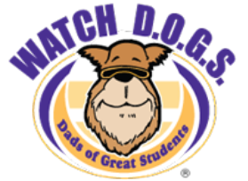
Mark your calendars for this year’s annual
Watch D.O.G.S. Pizza night!
Thursday, October 11, 6:30-7:30pm
Redland Oaks Elementary
We will be in the Cafeteria
Children are invited

Mark your calendars for this year’s annual
Watch D.O.G.S. Pizza night!
Thursday, October 11, 6:30-7:30pm
Redland Oaks Elementary
We will be in the Cafeteria
Children are invited

